MVC Flowchart

**Components of MVC**

MVC basically contain 3 components.

1. **Model** – Model is a wrapper which hold the data.
2. **View** – Representation of UI or Views in the hierarchy.
3. **Controller** – Controller act as a mediator between view and model and hold the business logics.

Each component have its own work and they combine together to give structure to your app.

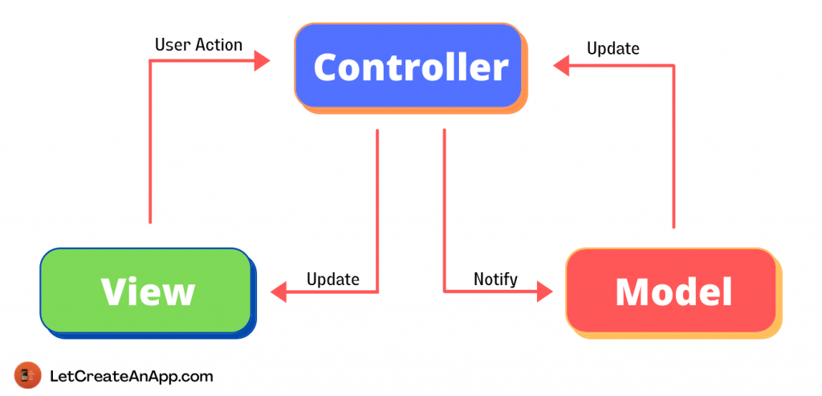

**Data flow in MVC**

In the above image, We are showing data flow between the different components of MVC. This data flow will take in 2 direction.

1. **View –> Controller –> Model** in this flow user take action on the view and that action will take by view controller and perform some API calls and fetch the data. Now views will get update by this data which is coming from the API.

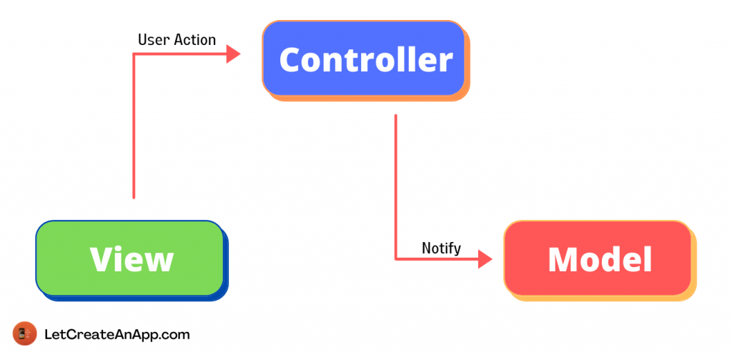

1. **Model –> Controller — View** in this flow when API fetch the data we will fill the model with the data and then model will update variables on the controller. Now after variables get updated, controller update the views.

